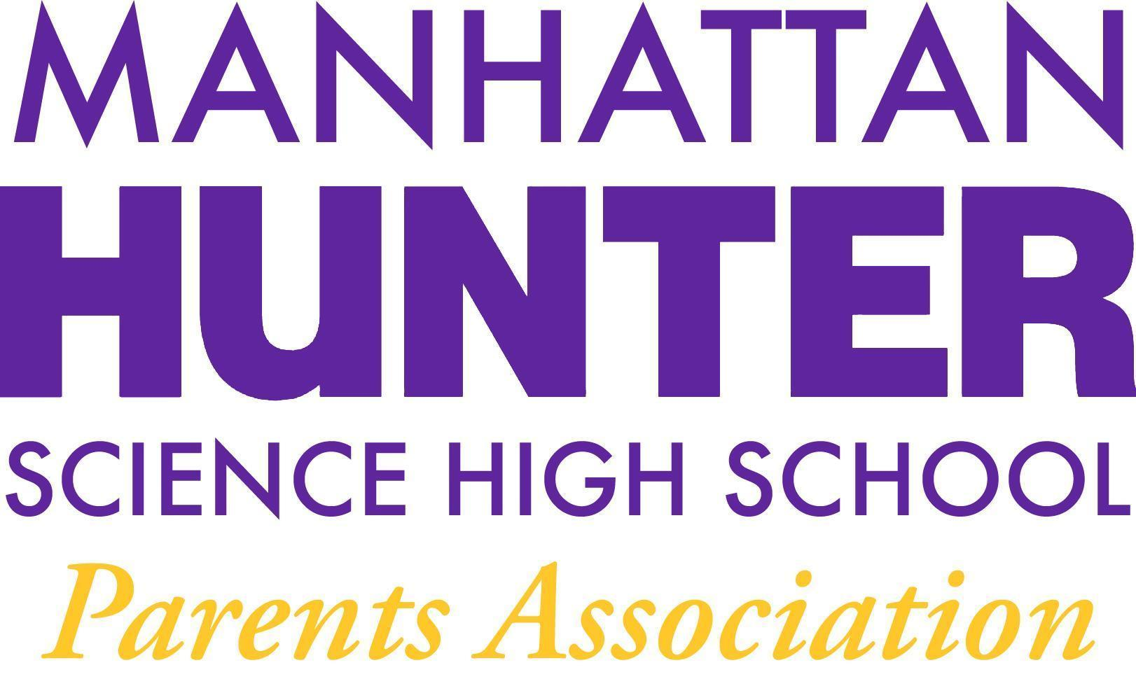
AGENDA
Manhattan Hunter Science High School Parents Association
General Membership Meeting
Tuesday,January 18, 2021
8:30am-9:30am (Via Zoom)

- Meeting call to Order
- Approval: October, November, December 2021 Minutes Approval
- Monthly Financials Review
  - Income
    - “From Thanks to Love” - $3,500
  - Upcoming/Recent Expenses
    - Xmas Party
    - Mixers
    - Senior Class Movie
- PA Announcements
  - MHPC - Letter in Support of Remote Option
  - Shout out to decorations down volunteers!
  - Website Design Committee - parent, student and teacher input
  - Spring Fling! (Online Auction committee formation)
- Q&A with Dr. Froner

