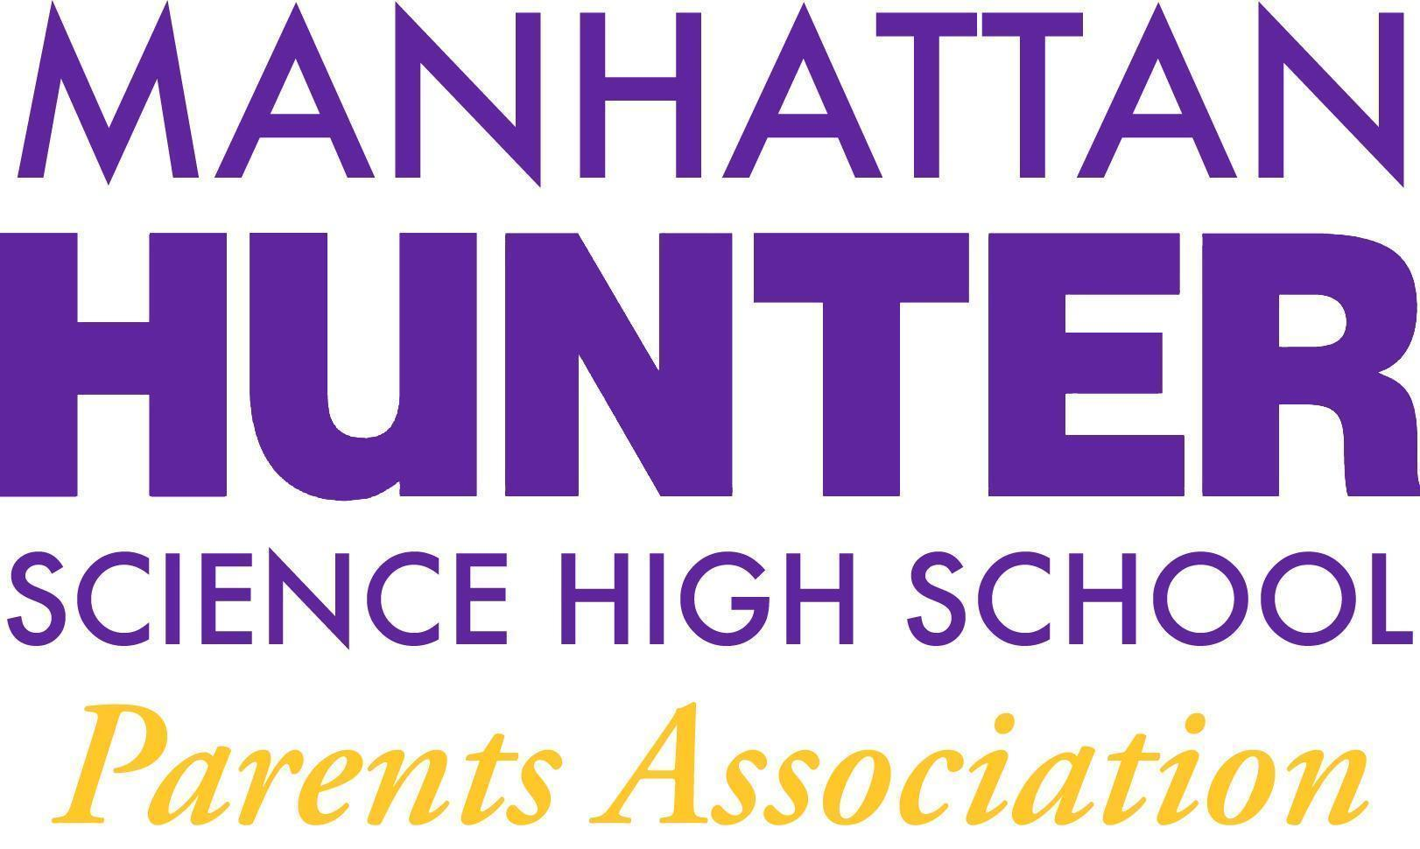
AGENDA
Manhattan Hunter Science High School Parents Association
General Membership Meeting
Tuesday,February 16, 2021
05:30pm (Via Zoom)

- Meeting call to Order
- January 2022 Minutes Approval
- Monthly Financials Review
  - Income and bank balance - $36,215.34
  - Upcoming/Recent Expenses
    - Young Men’s Empowerment Lunches
    - Mixers
    - Senior Class Movie
    - Staff Lunch (Jan 27 and March 3)
    - Staff Care Packages (Valentine’s Day)
    - BSU Lunch
- PA Announcements
  - Capital Funding Projects Ideas
  - DOE Parent Survey 2022
  - Website Design Committee - parent, student and teacher input
  - Spring Fling! (Online Happy Hour and Raffle)
    - Tickets - Broadway Show, Restaurant, Chromebook/Ipad, Other?
- Q&A with Dr. Froner

