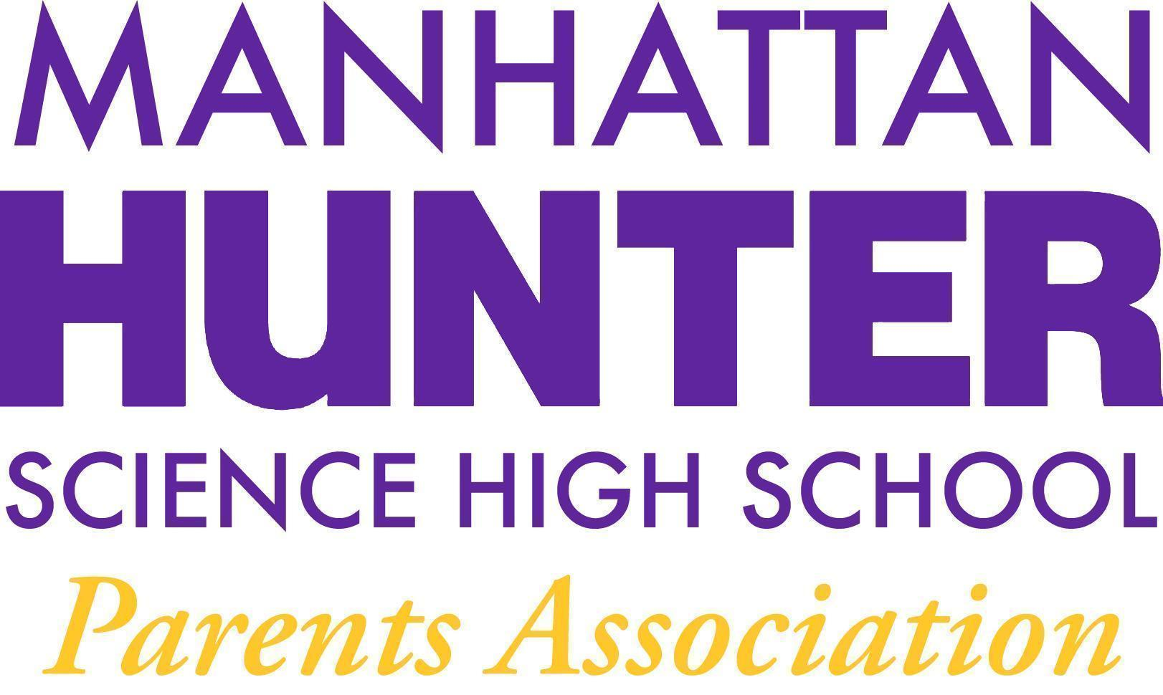
AGENDA
Manhattan Hunter Science High School Parents Association
General Membership Meeting
Tuesday, April 26, 2022
05:30pm (Via Zoom)

- Meeting call to Order
- AP Pam Wilks - Junior Year Preparations for College
- March 2022 Minutes Approval
- Monthly Financials Review
  - Income and Bank balance
  - Upcoming/Recent Expenses
    - $1500 + 600 (t-shirts) for botany - vote
- PA Announcements
  - PA Executive Board and SLT Election - May 2022
  - Ukraine/Russia Giving - $500 raised
  - Financial Literacy Course Update
  - Culinary Club/Cooking Club Update
  - Bathroom Beautification Committee (and Vaping) Update
  - Homecoming/End of Year Celebration - Senior Symposium
  - Website Design Committee

Executive Board - Slate - 2022/2023
Heather Tait - President
Barry Daub - VP (Hunter College Liaison)
Shari Hoenig - VP
Kristen Berger - Recording Secretary
Rachel Spiers - Treasurer

