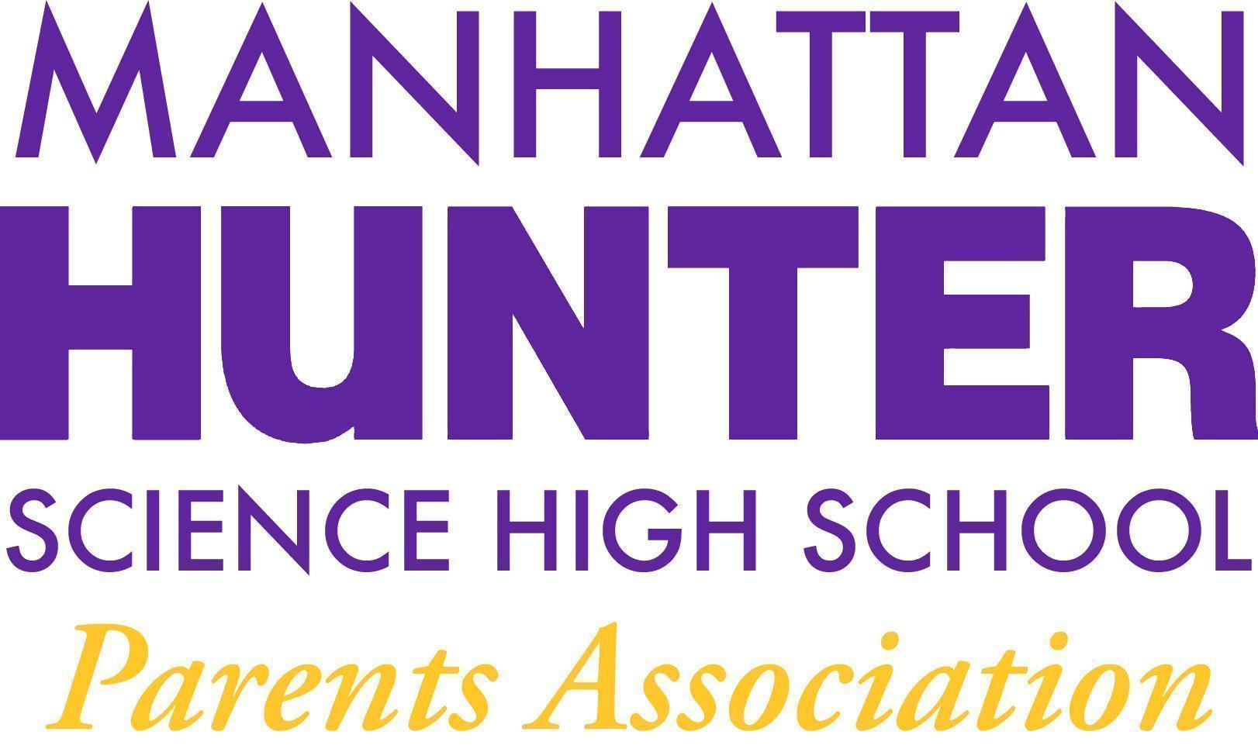
AGENDA
Manhattan Hunter Science High School Parents Association
General Membership Meeting
Tuesday, June 14, 2022
08:30am (Via Zoom)

- Meeting call to Order
- May 2022 Minutes Approval
- 2022/2023 SLT Election/Slate Ratification (see below)
- June SLT Report
- 2021/2022 Financials Review - Current State v. Future State
- PA Announcements
  - Uniform collection/policy
- Q&A with Dr. Froner

School Leadership Team - Parent Slate - 2022/2023
Heather Tait - President or President’s Designee
Barry Daub - TO BE APPROVED BY MEMBERS
Kristen Berger - 2nd year of 2 year term

