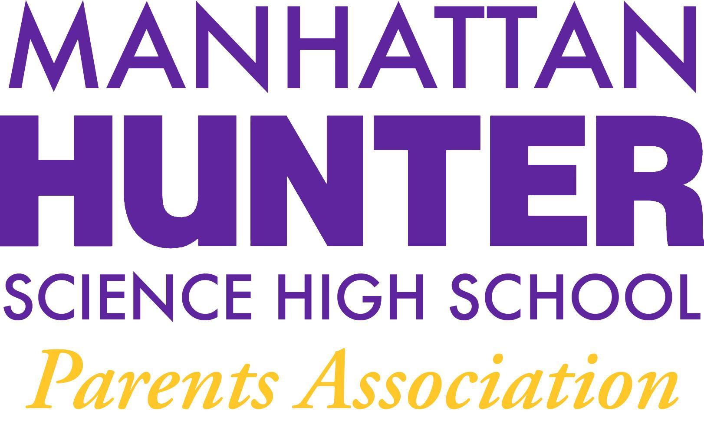
AGENDA
Manhattan Hunter Science High School Parents Association
Tuesday, September 21, 2021
8:30am

- Call to Order
- PA Business
  - Approval of June 2021 Minutes (Table until Oct 2021)
  - Approval of 2021-2022 PA Budget
  - 2021-2022 PA Secretary and SLT Election (October 2021)
  - Availability of School Uniforms
  - Congratulations Marilyn Arias
  - Upcoming Events: Back to School Night – September 30, 2021 5:30pm
- Open Dialogue with Dr. Froner
- Adjournment
NOTES AND ACTION ITEMS

