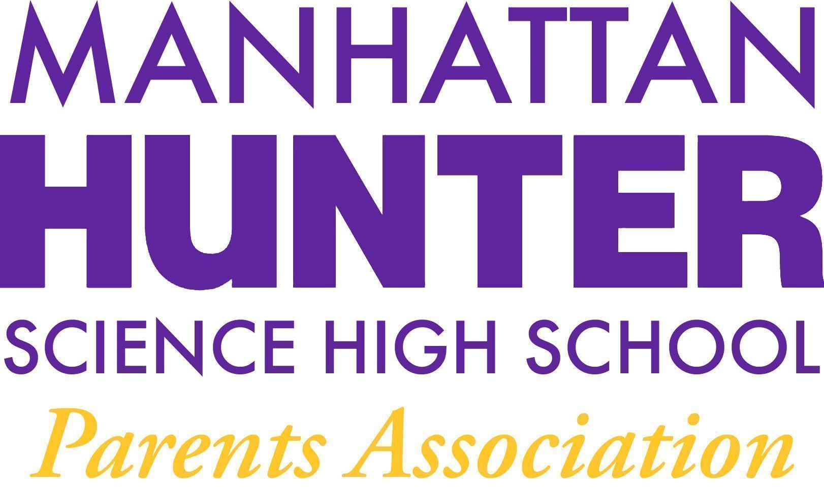
NOTES
Manhattan Hunter Science High School Parents Association
General Membership Meeting
Tuesday, May 17, 2022
08:30am (Via Zoom)

The meeting was called to Order at 8:33am

- Members reviewed and approved the April 2022 Minutes by a show of hands
- Members reviewed and approved the 2022/2023 PA Executive Board Election/Slate by a show of hands (the election was uncontested)
- The new EB called for more volunteers and co-positions on the EB will be available through next year.
- The EB asked members to approve an additional $5,000 for end of the year activities including mixers and senior trips - members approved the additional funds by a show of hands
PA Announcements
- The SLT Election will be held in June 2022 - there is one open parent seat and Barry Daub is the current candidate
- In addition to $500 raised, the students also have been donating goods for the displaced people of the Ukraine/Russia conflict. The PA will box the items and give them to an International distribution center In Yonkers in early June 2022.
- The website design committee continues it’s work and the final meeting of the current committee will be in late May 2022.
- Financial Literacy Course Update - incoming EB is working with admin and students to set up a financial literacy and life skills class (during advisory) for the 2022/2023 year
- Bathroom Beautification Committee - the bathrooms are in good shape, there are some leaks in the walls and the custodian on the MLK campus is working to address.

Q&A with Dr. Froner
- Vaping - students are vaping in the school bathrooms and this is a national/citywide issue as well. The school will send out a survey and work with student to support them in quitting by understanding why they are vaping and the consequences to their health and the health of the students around them. The school will also provide resources for quitting.
  - Michelle P is drafting a vaping student survey (anonymous) for the student so they can express their frustrations around vaping and the school can better understand the root cause of the increase in incidences.
- Mental health/Stress
  - Mental health deterioration for students and families was discussed and Dr. Froner stressed the importance of a school and family partnership to identify the signs of stress in students.
- Teacher absences
  - Several teachers have been absent lately with Covid or non-covid related illnesses. The school has hired permanent subs to help fill the gaps. Dr. Froner asked for parents patience as the school and city manage time off for illness

The Meeting was adjourned at 9:32am

Executive Board - Slate - 2022/2023
Heather Tait - President
Barry Daub - VP (Hunter College Liaison)
Shari Hoenig - VP
Kristen Berger - Recording Secretary
Rachel Spiers - Treasurer

