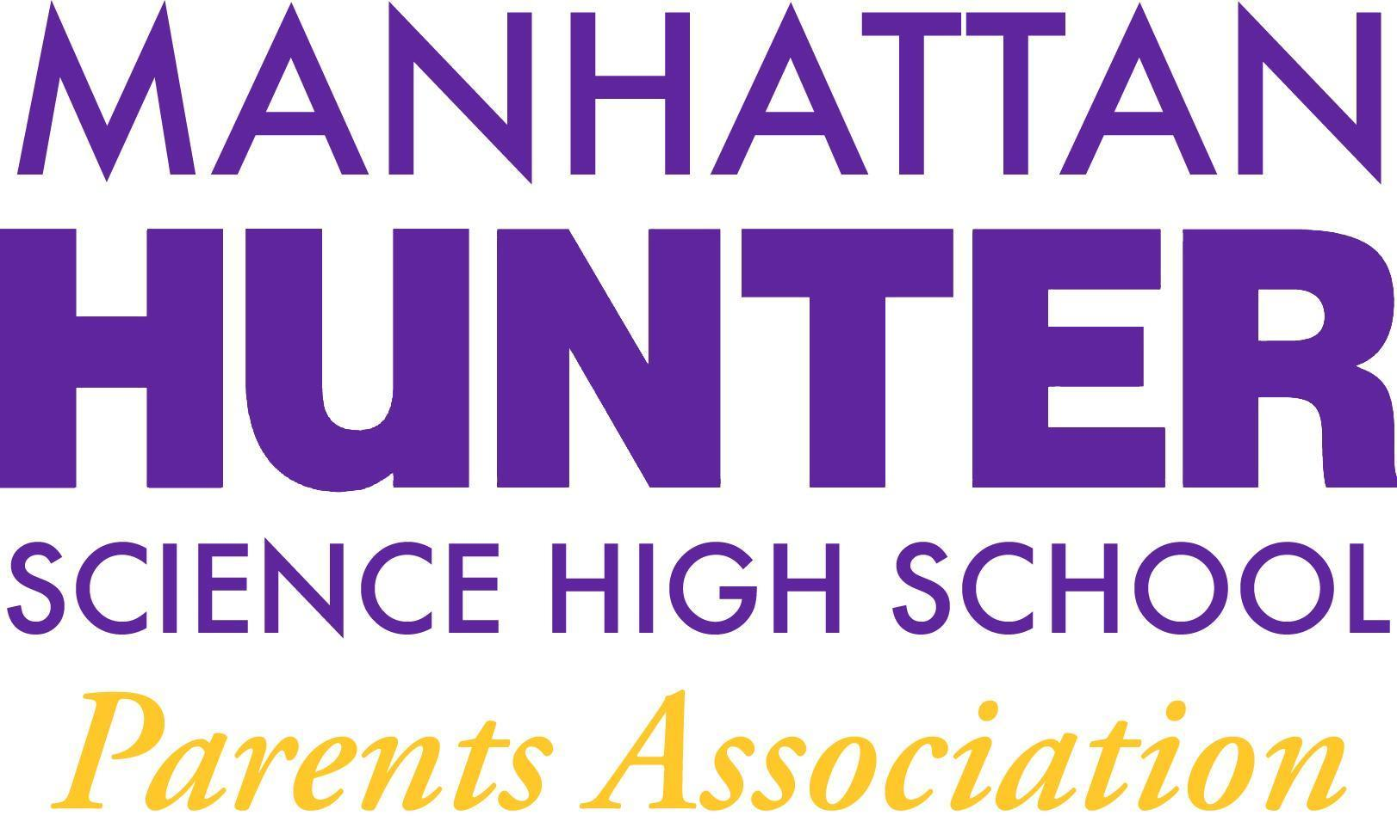
MEETING NOTES
Manhattan Hunter Science High School Parents Association
Tuesday, September 21, 2021
8:30am

- The meeting was called to order by the PA President and seconded by a member of membership
- The announcement was made that the meeting was being recorded and to please add your questions to the chat and they would be addressed in turn; all participants were also reminded to mute during the meeting.
- The PA Business agenda was reviewed
  - Approval of June 2021 Minutes (Tabled until Oct 2021 pending the review of the June notes from the prior PA president)
  - 2021-2022 PA Secretary and SLT Election (October 2021) - members were asked if anyone wanted to volunteer for one SLT position and one PA Secretary.
  - An announcement was made that there are school uniform t-shirts are available in the main office (100+ in stock) and are being sold for $5 per shirt.
  - Congratulations were made to Marilyn Arias - who is no longer MHSHS Parent Coordinator but is now a school social worker. Marilyn’s PC replacement has yet to be named. Marilyn also spoke briefly about Back To School Night (09/30/2021 at 5300pm) - parents will receive an email with the information about the virtual event in the next few days.
  - The PA announced the 2021-2022 budget and reviewed the items therein. Amazon Smile and other means for making donations to the school were discussed. Membership was asked to vote on the budget and a majority of raised hands approved the budget. There were no abstentions and no objections.
- Open Dialogue (Q&A) with Dr. Froner (please refer to the recording for specifics)
  - Check ins, breathing, Mindfulness and Music as part of every day
  - Covid testing, vaccinations for students and school ventilation system updates
  - SAT and PSATs will be held at the school this year
  - PSAL - Sciarrone will send a note to Parents with the PSAL information (a previous email was sent to students late in the summer)
  - Musical instruments (keyboard) upgrades from the PA/parents
  - Jupiter settings and email communications and google classroom sign up
  - Lunchtime and indoor v. outdoor seating/soccer field
  - The rationale for taking student’s phones at the start of every day
- Adjournment at 930am

