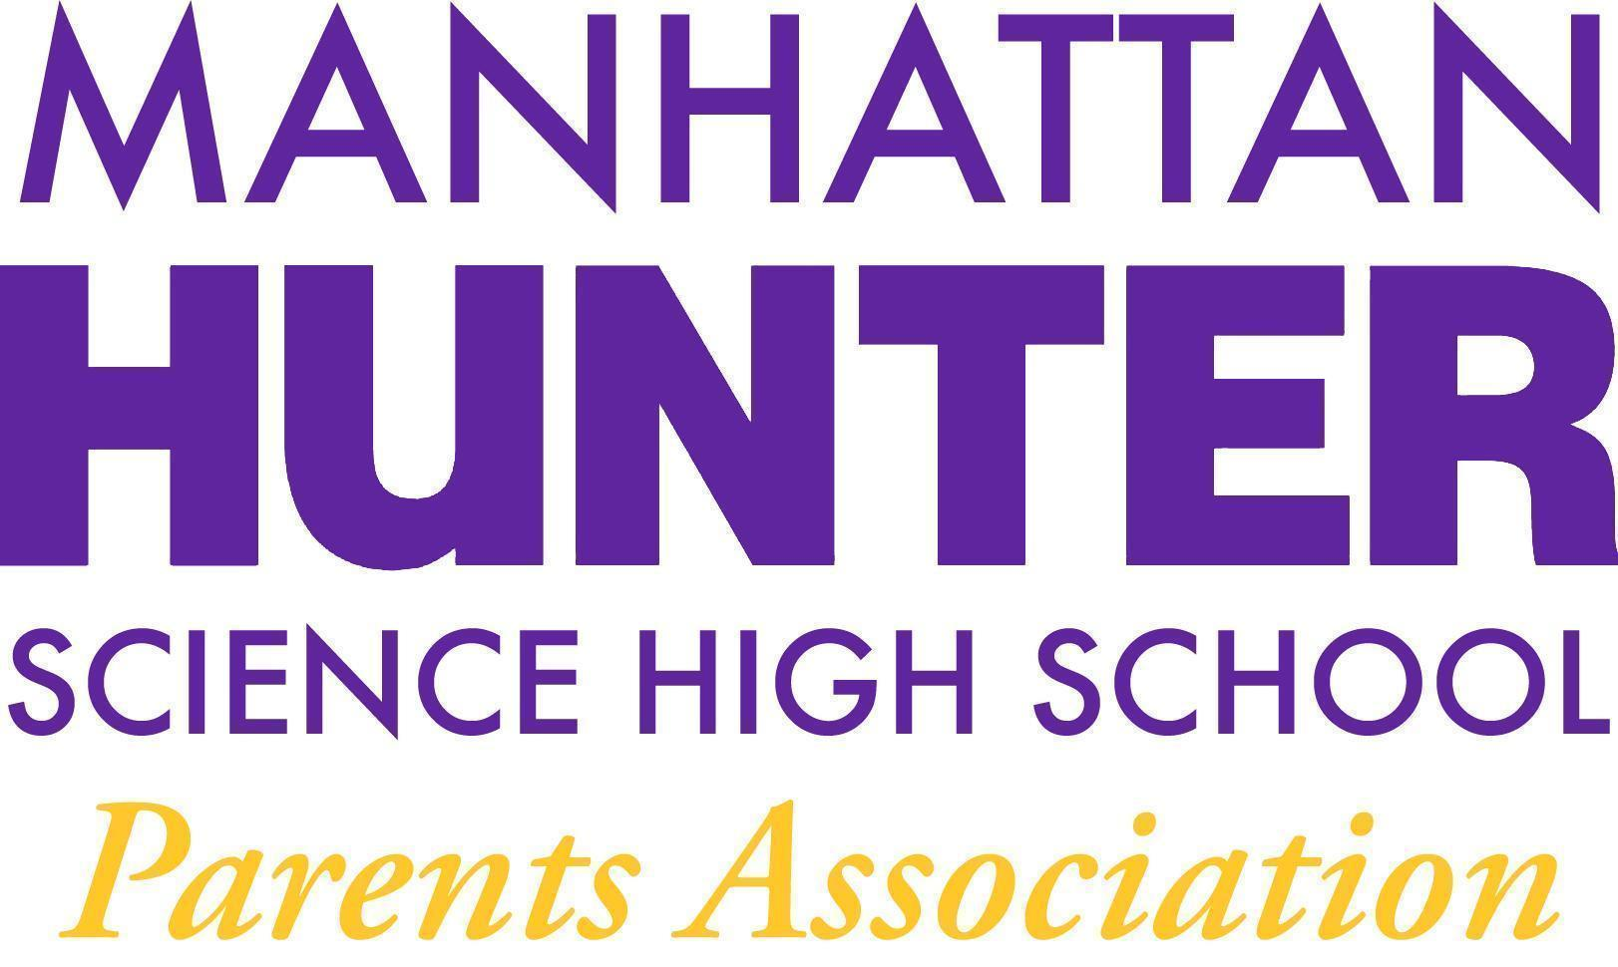
NOTES
Manhattan Hunter Science High School Parents Association
General Membership Meeting
Tuesday, March 22, 2022
08:30am (Via Zoom)

The meeting was called to Order at 8:33am
The February 2022 Minutes were approved by a majority show of hands
Monthly Financials Review
  - Bank balance $33,168
    - Income +$1,500 (Company Match)
  - Upcoming/Recent Expenses
    - Empowerment Groups ($70 per meeting)
    - Mixers ($800 per meeting)
    - Data Team lunch and Care packages for teachers ($250/$650)
    - Other Upcoming:
      - Breaking bread Afterschool Program ($750/$250) for decorations and food
      - snacks for clubs ($500)
      - break bread together afterschool ($750)
    - Flowers for hallways ($500)
- PA Announcements
  - Spring/March 31 Newsletter is coming and will be divided by class - to see if that format works a bit better for parent communication purposes
  - Ukraine/Russia Giving - Mr. Sinchi and Ms. Wilks are collecting items with the students to send to the Ukraine. Please be on the lookout for announcements.
  - Bathroom Beautification Committee - will go to the school on April 1 to look at the bathrooms and see what needs to be done to improve them Please join us if you are so inclined.
  - DOE Parent Survey 2022 - due March 25th - please fill out the survey - your voice counts! Alex will send parents a reminder.
  - Homecoming/End of Year Celebration - Senior Symposium - planning for this year end party for all the students is in process.
  - Website Design Committee - parent, student and teachers are working hard to revamp the website - please take a look at the website when you can or better yet, join the committee! www.mhshs.org
The Q&A with Dr. Froner (Topics)
- PSAT/SAT - IEP and 504; no phones policy
  - The no phones policy is a college board policy
  - the IEP and 504 students names and information was sent to College Board on behalf of parents by Ms. Farulla so they will be granted extra time during the test.
- Breaking Bread Afterschool Program
  - Muslim and Jewish students will eat together march 31 for Ramadan and then when Ramadan is done - they will break the fast with a traditional jewish meal. There will also be suitable decorations and discussion around the Middle East conflict and tolerance.
- Clubs - the PA EB will review our options for these additional clubs and report back to Members with options in April.
  - Financial Literacy
  - Culinary Club/Cooking
- Vending Machines (cafeteria) - the cafeteria vending machines are in working order.
- Covid/Masks Update - about 50/60% of the students are wearing masks in school.
- SYEP - Summer Youth Employment Program
  - Apply by April 22
  - Lottery
  - Students ages 14-24 are eligible
  - Students are paid $15 per hour to work at certain organizations depending on their age and where they live. Alex will send the information re: SYEP over Jupiter today.

The meeting was adjourned at 9:17am

