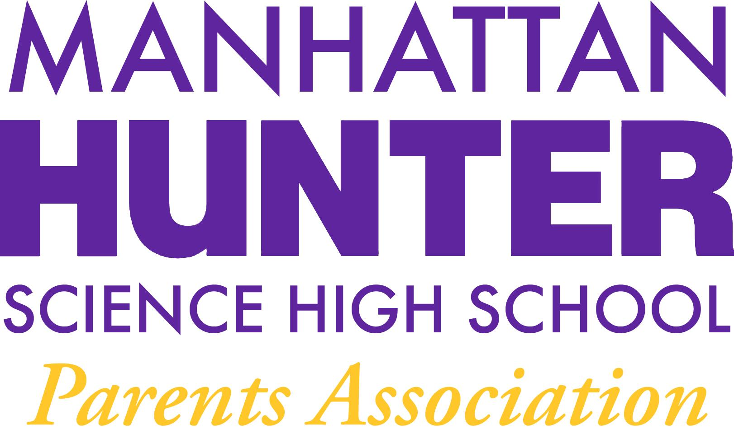
AGENDA
Manhattan Hunter Science High School Parents Association
General Membership Meeting
Tuesday, October 19, 2021
5:30-6:30pm (Via Zoom)

- Meeting call to Order
- Approval September Minutes
- October Expenses and Financials Review
- 2021-2022 Election
  - SLT Parent Position
    - Kristen Berger
  - PA Co-Secretary and Co-Treasurer
    - Lisa Byala and Rachel Spiers
- PA Announcements
  - Do you want to be a Co-member of the PA?
  - Botany Club Update, Amazon Smile and Monthly Giving
  - Uniform Page and Uniform Exchange Volunteers
  - Decorations Committee Volunteers
- College Readiness for Grades 9-11 with Assistant Principal Pam Wilks
- Q&A with Dr. Froner

