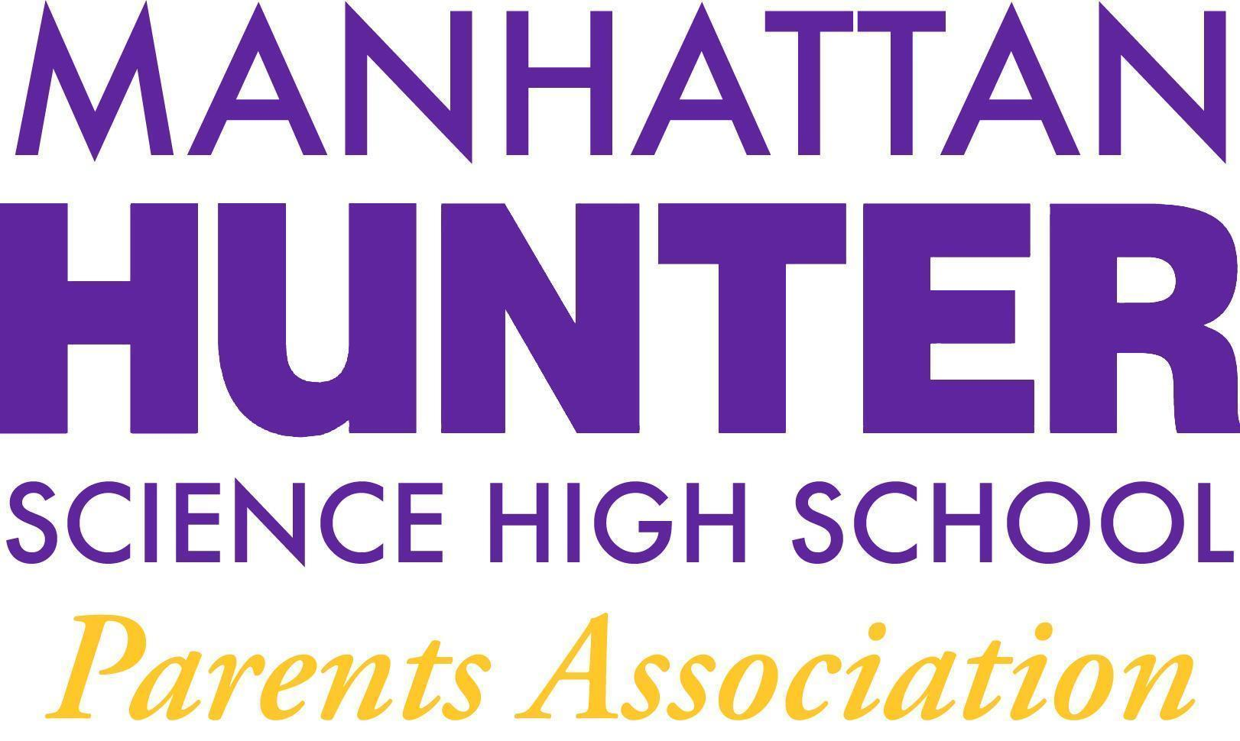
NOTES
Manhattan Hunter Science High School Parents Association
General Membership Meeting
Wednesday,February 16, 2021
05:30pm (Via Zoom)

The Meeting was called to Order at 6:34pm

The January 2022 Minutes were approved by majority approval

Monthly Financials Review
The bank balance - $36,215.34
Upcoming/Recent Expenses were as follows.
    - Young Men’s Empowerment Lunches
    - Junior and Senior Mixers
    - Senior Class Movie (Spiderman and Scream2)
    - Staff Lunch (Jan 27 and March 3)
    - Staff Care Packages (Valentine’s Day)
    - Black Student Union Lunch
PA Announcements
We need your input Capital Funding Projects Ideas - we have the an RFP for 50k for a capital improvement for MHSHS.
Bathroom re-do? We need your ideas!

DOE Parent Survey 2022 - please remember to fill out the survey - it’s very important to the school and the staff that they receive honest feedback about how to improve.

Website Design Committee - parent, student and teacher input - please help by joining the committee or just reviewing the content on the website and emailing your feedback to the PA.

PA Spring Fling Fundraiser! (Online Happy Hour and Raffle) - do you have any connections with tickets - Broadway Show, Restaurant, Chromebook/Ipad etc.
- Q&A with Dr. Froner
  - Topics
    - The 24 HW policy rule was discussed - HW is due no earlier than 24 hours from the time it was assigned. teachers do not have to assign work through google classroom.
    - Covid Restrictions - in place as usual until we hear otherwise.
    - Lateness/detention policy - the email that went out had unintended consequences. The lateness policy is being reviewed and another email will be sent to parents/students. Exceptions will be made for train problems and scanning delays.
    - A parent suggested that vending machines be reinstalled at the school. The PA wil research “healthy alternatives” and water vending machines that take debit/credit cards.
    - Senior Class homecoming was suggested and Dr. Froner discussed the idea of a day for seniors and their teachers to reconnect in the Spring.
    - The teachers and staff are very grateful for all the food and support from the PA; the student mixers have been a big hit - the most recent was the male student fashion show which was really well received and made for a terrific day for students.

Meeting Adjourned at 6:30pm

