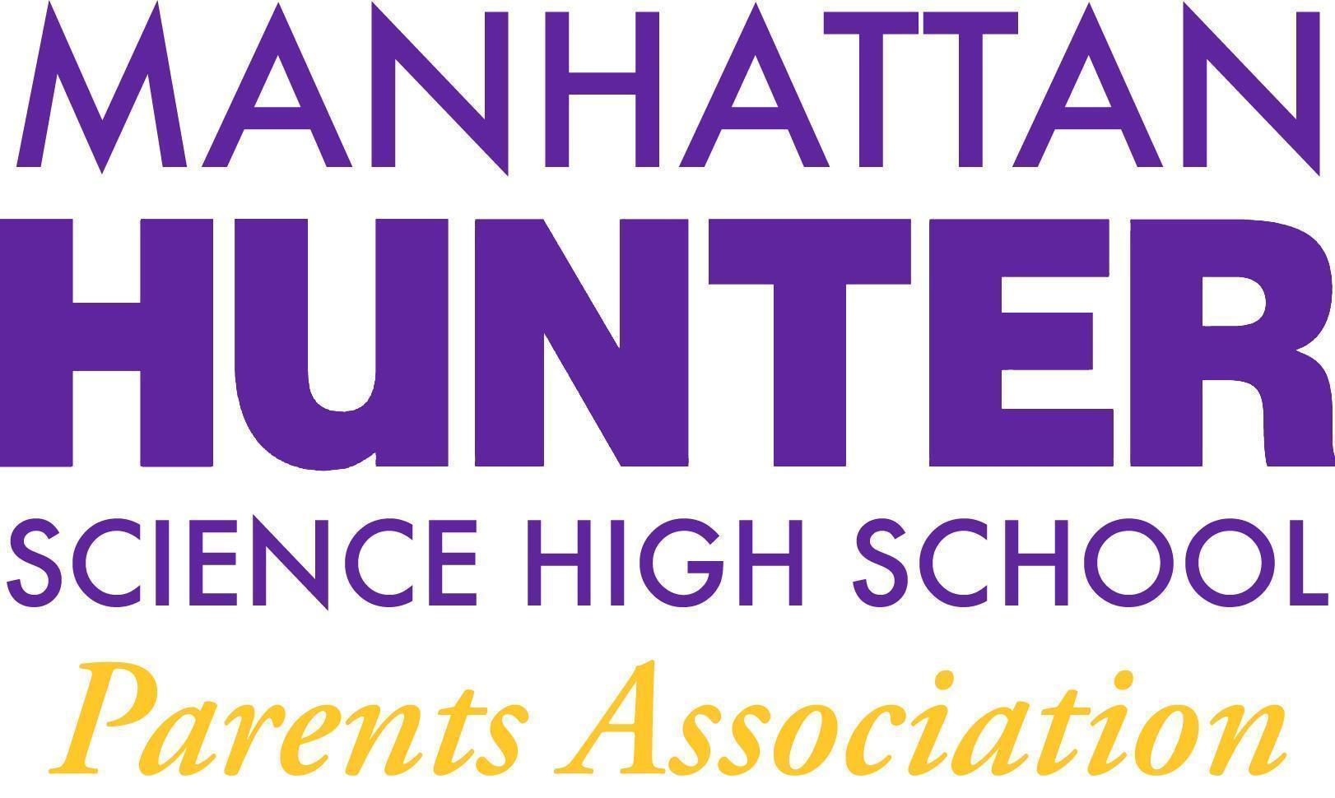
NOTES
Manhattan Hunter Science High School Parents Association
General Membership Meeting
Tuesday,January 18, 2021
8:30am-9:30am (Via Zoom)

The meeting was called to order at 8:32am

The PA Members approved the notes from the October, November, December 2021 meetings with a majority vote. The notes will be posted on the website.

Monthly Financials Review
- Our fundraiser - “From Thanks to Love” raised our goal of $3,500; and now we will receive a 1:1 match for an additional $3,500!

Recent Expenses
- Mixers - potentially 2 more in January - the cost is $650 each for pizza and drinks - the dates for the mixers will be posted to the school google calendar
- Senior Class Movie - $350 to rent private movie showing for our student - Movie TBD (01/27/2022) at 42nd Street AMC Theater

PA Announcements
- We shouted out our holiday decorations up and down volunteers - the school looked beautiful and it certainly cheered the students and teachers.
- Website Design Committee - parent, student and teacher input is needed - the meeting is 01/26 at 6pm if anyone wants to join in the endeavor
- Spring Fling! (Online Auction committee formation) - more updates on this in February and March 2022. Please let the PA EB know if you can donate items for auction.
Q&A with Dr. Froner
- Remote Option - the PA had a discussion regarding the parent’s position on the Chancellor/major’s on going discussion regarding a NYC schools remote option
  - Those for supporting the option
    - Cited risk and family members who are vulnerable and a wish to keep their students connected and engaged in school when they are home
  - Those against supporting the option
    - Cited that there is no concrete plan from the Chancellor and it’s difficult to support and option when we do not have any idea as to how it will be implemented
  - Dr. Froner’s suggestions
    - Ensure that teacher’s union has agreed to synchronous teaching
      - MHSHS would be ready if the word was given to stream into class sessions.
      - Students would use laptops and a buddy system to ensure students are connected and have a point person/buddy for any questions.
    - The idea of an evening session for remote students was discussed - perhaps 3-5pm on school days - paying teachers and administration per session to implement.
  - The PA will draft a response to the Chancellor and Mayor citing our support for the remote option and our concerns around implementation. The response will be drafted and circulated to parents before it’s submitted so they can review and weigh in.
- Testing and return to school
  - Parents were concerned that the students who had Covid and returned after 10 days of quarantine would test positive if randomly tested by the school. Dr. Froner will investigate what the protocol is for these students and revert to the parent body.
- When students are voluntarily quarantining - what is the ramification for their recorded absences?
  - Dr. Froner explained the following and will review these protocols with the testing office and revert to parents in case there are any changes.
    - students who are vaccinated or unvaccinated and exposed with no symptoms (should test immediately with the DOE provided tests) and continue to attend unless they test positive
      - if parents choose to keep students home who are not showing symptoms after an exposure and have not tested positive, will be marked absent.
    - students who are exposed and have symptoms should not be marked absent but “excused” regardless of vaccination status.
    - Aside: College admissions is not taking absences into account during the college process this year.

Meeting Adjourned 9:20am

