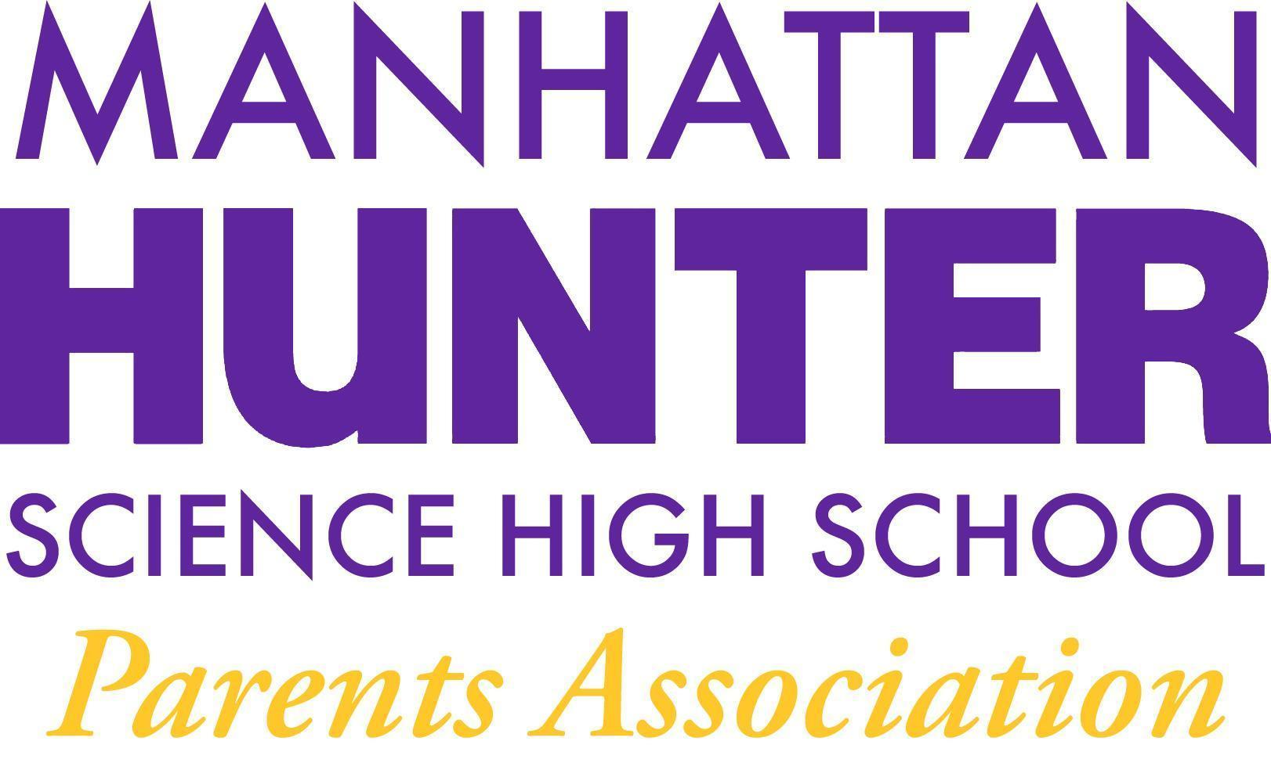
MEETING NOTES
Manhattan Hunter Science High School Parents Association
Tuesday, October 19, 2021
5:30pm

- The meeting was called to order
- The announcement was made that the meeting was being recorded and to please add your questions to the chat and they would be addressed in turn; all participants were also reminded to mute during the meeting.
- The PA Business:
  - The September 2021 Minutes approved
  - 2021-2022 Elections
    - SLT Election uncontested: Kristen Berger approved
    - PA Secretary Election uncontested: Lisa Byala approved
    - PA Co Treasurer Election uncontested: Rachel Spiers approved
  - PA EB made an announcement that Parents should reach out to volunteer at the school and for the PA. There are always Co PA positions available for interested parents.
  - PA member Michelle Puissant spoke about the Botany Club needs and that were funded through Amazon Smile.
  - PA EB School website mhshs.org was briefly reviewed and the uniform information page was reviewed as updated.
  - PA EB stressed importance of fundraising for general funds as well as project directed monies.
  - The current bank account and yearly budget size was briefly discussed. There is about 45k in the bank and 7k is spoken for in allocated expenses including: private buses, books for Juniors, pizza for the freshman mixer and unreimbursed expenses from the 2020-2021 school year etc.
- Pam Wilks, the AP at the College spoke about college prep including advisory morphing into ACT and Sat prep in 11th grade though they will continue to offer Social Emotional Learning (SEL) to 11th grader.
- MHSHS only offers one year of a language although some colleges require 3 years for admission. Ms. Wilks noted that colleges will not punish the student of their HS did not offer the language years. If there are individual concerns around language requirements, parents should reach out to Ms. Wilks or Dr. Froner.
- Community Service is done as a School and encouraged; community service was cancelled last year due to Covid but will be re-instituted this year.
- Clubs will be restarting virtually and in person. Parents are encouraged to share their children's interests for Clubs and school and PA will try to make them happen.
- Parents asked questions about grades and the transition back to the classroom. Mr. Sinchi encouraged parents to reach out to teachers first and build relationships; the school is monitoring the student’s progress and transition back to the classroom post Covid.

Meeting adjourned at 620pm

